Online Examination System



**Business Requirements Specification**

**Online Examination System**

Author: Mohanapriya Logapriyan

Creation Date: 03 May 2016

Version: 1.0

**Instructor: Dr. Jing-Chiou Liou**

**Course ID: CPS5995**

TABLE OF CONTENTS

INTRODUCTION 3

Purpose of requirement specification document 3

Project Overview 3

Project Purpose 3

Project Scope 3

Requirement ID Nomenclature 3

PROJECT/SERVICE DESCRIPTION 4

ProJECT Context 4

User Characteristics 4

Assumptions 5

Constraints 5

Dependencies 5

REQUIREMENTS 6

Functional Requirements 6

Hardware Requirements 8

Software Requirements 8

performance Requirements 8

security requirements 8

availability requirements 9

portability requirements 9

user interface requirements 9

manageability/maintainability 10

USER SCENARIOS/USE CASES 11

UML Diagram 11

APPENDIX A 14

reference materials: 14

APPROVALS 15

Sign-off Sheet 15

INTRODUCTION

Purpose of requirement specification document

This document details the functionalities required for an online Examination system, the system that allows to conduct examinations online to registered set of students of a particular course created by the test conductor.

Project Overview

Today **Online Examination System** has become a fast growing examination method because of its speed and accuracy. It is also need less manpower to execute the examination. Most of universities can conduct their objective exams by online examination system. Universities can also easily check the performance of the students.

Project Purpose

* This web application facilitates to conduct examinations online.
* It allows a number of students to attend the examination at the same time and displays the results as the tests gets over.
* The Test conductor has the privilege to create course and upload the list of students to register under the course. He can create tests for the created course and conduct examinations for students registered for the course.

Project Scope

Scope of this project is very broad in terms of other manually taking exams.

Few of them are:

* Can be used anywhere any time as it is a web based application(user location doesn’t matter )
* No restriction that examiner has to be has to be present when the candidate takes the test. In case of need, a supervisor might be enough.
* Design to facilitate professors who conduct the tests and students who take the tests.
* Online examination is designed for educational institutes like schools, colleges and private institutes to conduct logic test of their students.
* The question type is objective.
* The test is timed in minutes which automatically end on time out and display the result.

Requirement ID Nomenclature

All the requirements in this document are given an Id in the format of “Reqxxxx” where xxxx are decimal digits starting from Req0100 to Req0900 and the subparts are identified as Req01** so on and so forth.

PROJECT/SERVICE DESCRIPTION

This project is intended to be used as a web application. Once the Test conductor creates the tests, he can conduct for any more students by managing the time interval, the start date and end date of the test and also by sharing the test code of the tests to permit students to access the test.

Project Context

* Admin (super user) can create the account for test conductors.
* Test conductors can create and conduct the test for their courses.
* Students can attend tests and view their results.

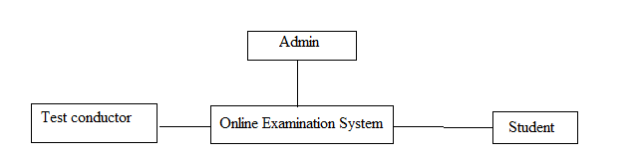

OES – Context Diagram

User Characteristics

No technical training or education is required to use this system. Basic computer knowledge is enough to access the system.

Our intended users are Professors (or Test conductors) and Students (or Test attendees).

Assumptions

* + The Examination questions are objective and multiple choice.
  + The Examinations are timed in minutes
  + Student can give the each exam just once.
  + Test conductor can view the results of respective students only.
  + There is only one admin/super user who creates Test conductor accounts.

Constraints

* Technical Constraints: N/A
* Budgetary Constraints:

This project is done with open source resources and hence approximately zero budget. Yet Software Quality is taken care of.

* Time Constraints:

It is well-known fact that any project can be improvised better provided more time.

* Environmental Constraints: N/A

Dependencies

This project is a stand-alone project which is independent and therefore doesn't interact with any other external software or database.

REQUIREMENTS

Functional Requirements

The Online Examination System is developed for handling the activities of Students, Test conductor and Admin. Everyone needs Internet connection to access the system as it is a web application.

**Admin**

**Req0100**: Admin can log-in into the System with correct user ID and password.

**Req0101**: Successful log in of admin should lead to admin home page.

**Req0102**: Admin can create the test conductor account.

**Req0103**: Admin can edit the test conductor account details (provided the dependent data doesn’t corrupt on editing the details)

**Req0104**: Admin can delete the test conductor account details (provided the dependent data doesn’t corrupt on editing the details)

**Test conductor**

**Req0201**: Test conductor can log-in into the System with correct user ID and password.

**Req0202**: Successful log in of Test conductor should lead to Test conductor home page.

**Req0203**: Test conductor can create the course for a particular semester and year.

**Req0204**: Test conductor can edit the course for a particular semester and year (provided the dependent data doesn’t corrupt on editing the details).

**Req0205**: Test conductor can delete the course for a particular semester and year (provided the dependent data doesn’t corrupt on editing the details).

**Req0206**: Test conductor can create the students account by uploading the csv file that list rows of student details. One for each student, mentioning the student id, student name

and student mail id.

**Req0207**: Test conductor can create the student account by using add student form that requires entering student id, student name and student mail id.

**Req0208**: Test conductor can edit the students account details.

**Req0209**: Test conductor can remove the students account for the course he created.

**Req0210**: System should set the student ID as first time password of students account.

**Req0211**: Test conductor can create the test for a course for a particular semester and year. [Test Details : start date, end date, test time, test code]

**Req0212**: Test conductor can edit the test details for a particular semester and year (provided the dependent data doesn’t corrupt on editing the details).

**Req0213**: Test conductor can delete the test details for a particular semester and year (provided the dependent data doesn’t corrupt on editing the details).

**Req0214**: Test conductor can create the questions for the test he created for a course.

**Req0215**: Test conductor can edit the questions for the test he created for a course (provided the dependent data doesn’t corrupt on editing the details).

**Req0216**: Test conductor can delete the questions for the test he created for a course (provided the dependent data doesn’t corrupt on editing the details).

**Req0217**: Test conductor can view the results of his students.

**Student**

**Req0301**: Student can login with his correct details [student id as password for the first time].

**Req0302**: Student should be prompted to change his password on first successful login.

**Req0303**: Successful log in of student should lead to student home page displaying the courses that he has registered for.

**Req0304**: Student can view the list of tests that he can appear for the course he registered.

**Req0305**:Student can take the test.

**Req0306**: Tests should be automatically submitted on time out.

**Req0307**: Student can view the results once the test is over.

Hardware Requirements

**Req0401:** The application demands all the PCs /Laptops to be connected to Internet.

**Req0402:** PC should be sufficiently fast with adequate memory at least 64 MB RAM and 2 GB hard disk space is required to run this application.

**Req0403:** Screen resolution of at least 800x600 pixels required to properly view the screen

**Req0404:** A web server is needed to deploy the application

**Req0405:** A Database server is needed to load the application data in the application database.

Software Requirements

**Req0501:** Any Windows Operating System

**Req0502 :** Any Browser like Google chrome, Microsoft edge or Mozilla Firefox

**Req0503:** XAMMP for PHP and MYSQL

Performance Requirements

**Req0601:** The navigation of web page by clicking any link should be within 10 secs.

**Req0602:** The action that involves database interaction should be processed within 30 secs.

**Req0603:** The input validations messages should be displayed within 5 secs on submitting the forms like Add Student, Add Course, etc…

Security Requirements

**Req0701:** Strict implementation of access control that student can view only his regarding and not other student or test conductor details

**Req0702:** Test conductor can access only his courses and students for those courses but not other Test conductor or student details

**Req0703:** Admin, the super user shouldn’t have any other control other than creating/editing test conductor accounts.

**Req0704:** System should be accessed only with correct credentials for admin, test conductor as well as student account.

**Req0705:** Copy and paste any intermediate link should request for credentials.

Availability Requirements

**Req0801 :** System should be available round the clock other than the time required for back up and system deployment outage.

Portability Requirements

**Req0901 :** System should be accessible anywhere provided a PC with Internet connection

User Interface Requirements

(Whole requirements are not measurable )

The user interacts with the application via website accessed with any browser.

**Req1001 Clear:** The layout should be simple and clear. It should not confuse the user.

**Req1002 Concise:** The wordings used in the application should be concise and easily understandable with no dual meanings.

**Req1003 Familiar:** The application should be easy to navigate for the users. The navigation buttons and links should be similar to those in most popular websites.

**Req1004 Consistent:** The Interface should be consistent across different browsers like Google chrome and Mozilla Firefox.

**Req1005 Efficient:** It should provide accurate and updated information at all times and present it in a format easily understandable by users.

**Req1006 Accessible:** The application should be self-explanatory by using appropriate labels and familiar navigational ways.

Manageability/Maintainability

Maintenance of the Online Examination System is similar to most web applications like taking the back up of database as well as archiving the database.

**Monitoring** **Req1101:** Archiving the database. It can be done by taking an sql dump or any other traditional ways

**Monitoring** **Req1102:** System has to be monitored for operational issues and versions with issues fixed have to be deployed as per ongoing need.

USER SCENARIOS/USE CASES

UML Diagram

Use-case Diagram - Admin

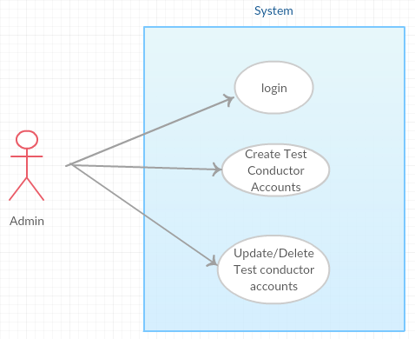

**Use case Diagram for Admin**

Use-case Diagram – Test conductor

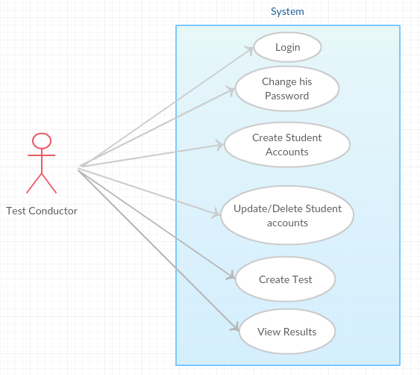

**Use case Diagram for Test Conductor**

Use-case Diagram – Student

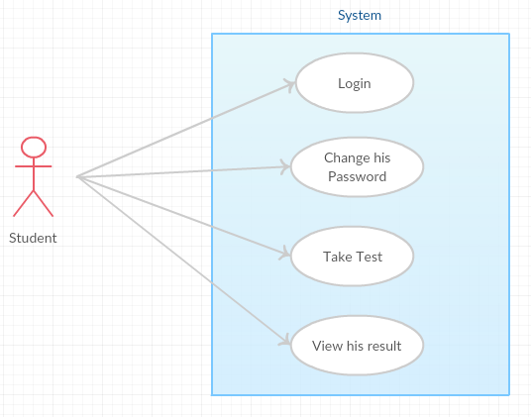

**Use case Diagram for Student**

APPENDIX A

Reference Materials

* https://www.oasis-open.org/committees/download.php/24846/Example-SoftwareDesignDocument-LegalXMLUtility.pdf
* http://www.academia.edu/7420194/Software_Requirements_Specification_for_Online_Examination_System_Software_Requirements_Specification_for_Online_Examination_System
* http://www.slideshare.net/joyau2009/online-examination-documentation-29476109
* http://www.ukessays.com/essays/computer-science/overview-on-developing-an-online-examination-system-computer-science-essay.php
* http://www.iftmuniversity.ac.in/iftmu/pages/coe/downloads/OnlineExam.pdf
* http://tusharghosh.wdfiles.com/local--files/projects/OpenGuru.pdf

APPROVALS

Sign-off Sheet

***We drafted the software requirements achieved till date by following the agile methodology and produced to sponsor’s acknowledgement.***

**Project Sponsor: Dr. Jing-Chiou Liou**

Date

**Project Manager: Mohanapriya Logapriyan**

Date

**Developer: Dipak Patel**

Date